California State University, Northridge

College of Engineering & Computer Science

Electrical and Computer Engineering Department

ECE 443L Digital Electronics Laboratory Report 9

CMOS Based ADC Circuit



By Haroutun Haroutunian

Abstract: After constructing the Analog-to-Digital Converter, students examine the Pulse Voltage supplies to alter input frequencies. Input frequencies alter the pulse, as seen in the output figures in Procedure.

Keywords: ADC, MSB, LSB, non-inverting

**9.1 Introduction**

Experiment 9 introduces students to Analog-to-Digital Circuits. ADCs are found in every electronic device, eg. Smartphones to convert volume on speakers, etc. The circuit consists of simple resistors, OpAmp, Voltage supplies to create inputs, and PMOS and NMOS transistors.

**9.2 Simulation and Experimental Set-up**

As seen in figure 9.1, the circuit is set up with common source and gate transistors. The circuit is set up where the Left-most is the Most Significant Bit, and the Right-most is the Least Significant Bit.

**9.3 Simulation and Experimental Results**

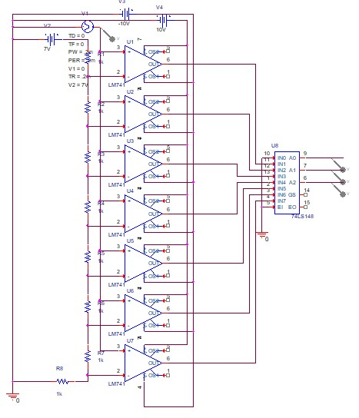

Figure 9.1 Case 2 7V Ramp Schematic with a freq @ 5kHz ADC Circuit

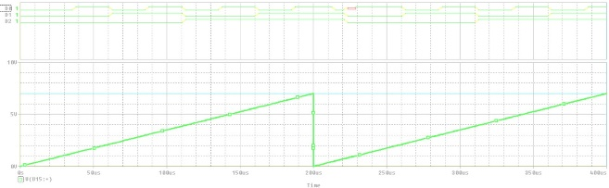

Figure 9.2 Case 2 Waveform 7V Ramp with a freq @ 5kHz ADC Circuit

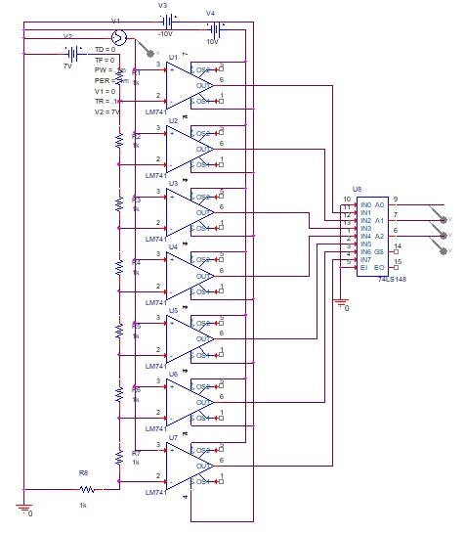

Figure 9.3 Case 4 7V Ramp Schematic with a freq @ 15kHz ADC Circuit

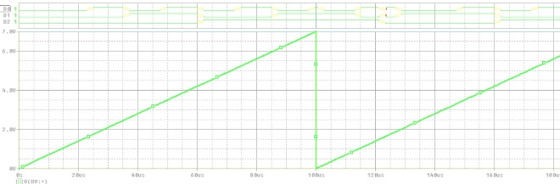

Figure 9.4 Case 4 Waveform 7V Ramp with a freq @ 5kHz ADC Circuit

**9.4 Discussion and Conclusion**

In experiment 8, students were exposed to the set-up and uses of ADC circuits. ADC is utilized in everyday electronic devices so real-world inputs can be read by the electronic device and output easy-to-read waveforms. The music industry is surrounded by ADC circuits since frequencies are input in analog or digital and converted.